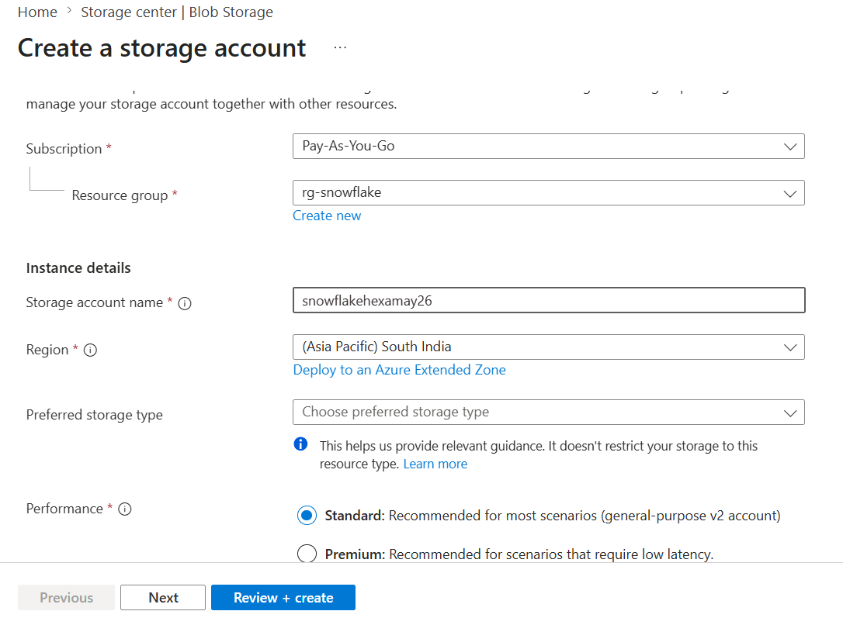

CREATE OR REPLACE DATABASE DEMO_DB;

USE DATABASE DEMO_DB;
-- create integration object that contains the access information
CREATE STORAGE INTEGRATION azure_integration
TYPE = EXTERNAL_STAGE
STORAGE_PROVIDER = AZURE
ENABLED = TRUE
AZURE_TENANT_ID = '51919faa-a7c3-43e9-bc7d-73c7742bc6a3'
STORAGE_ALLOWED_LOCATIONS = ('azure://snowflakehexamay26.blob.core.windows.net/csv', 'azure://snowflakehexamay26.blob.core.windows.net/json');

-- Describe integration object to provide access
DESC STORAGE integration azure_integration;

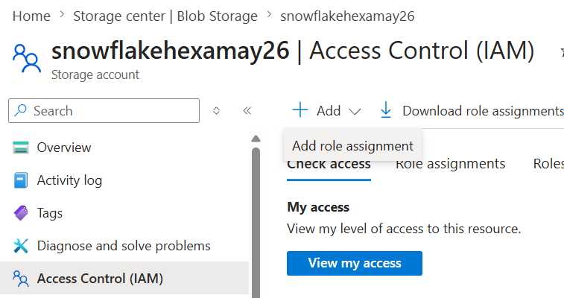

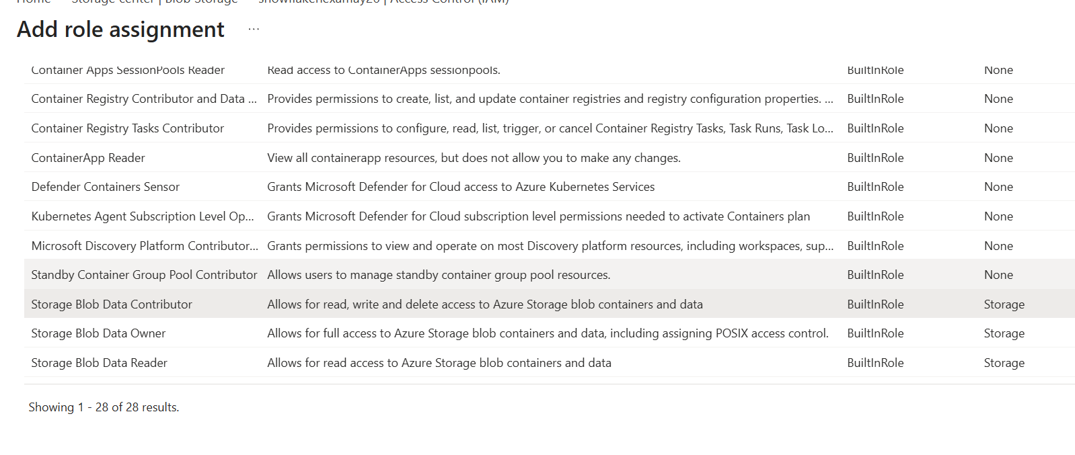

ADD MEMBER

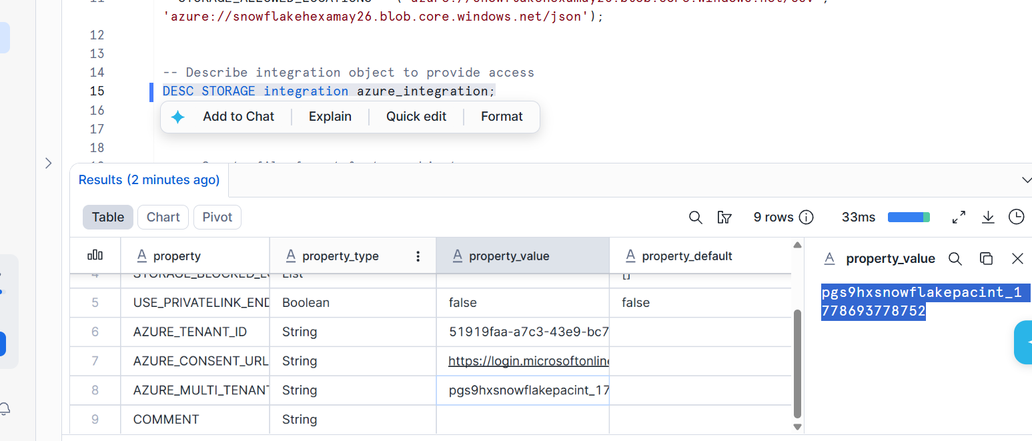

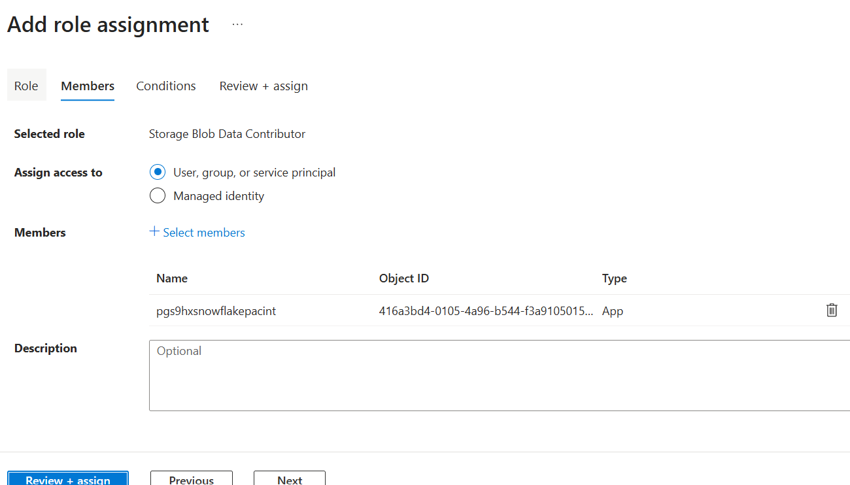

---- Create file format & stage objects ----

-- create file format
create or replace file format demo_db.public.fileformat_azure
TYPE = CSV
FIELD_DELIMITER = ','
SKIP_HEADER = 1;

-- create stage object
create or replace stage demo_db.public.stage_azure
STORAGE_INTEGRATION = azure_integration
URL = 'azure://snowflakehexamay26.blob.core.windows.net/csv'
FILE_FORMAT = fileformat_azure;

-- list files
LIST @demo_db.public.stage_azure;

---- Query files & Load data ----

--query files
SELECT
$1,
$2,
$3,
$4,
$5,
$6,
$7,
$8,
$9,
$10,
$11,
$12,
$13,
$14,
$15,
$16,
$17,
$18,
$19,
$20
FROM @demo_db.public.stage_azure;

create or replace table happiness (
country_name varchar,
regional_indicator varchar,
ladder_score number(4,3),
standard_error number(4,3),
upperwhisker number(4,3),
lowerwhisker number(4,3),
logged_gdp number(5,3),
social_support number(4,3),
healthy_life_expectancy number(5,3),
freedom_to_make_life_choices number(4,3),
generosity number(4,3),
perceptions_of_corruption number(4,3),
ladder_score_in_dystopia number(4,3),
explained_by_log_gpd_per_capita number(4,3),
explained_by_social_support number(4,3),
explained_by_healthy_life_expectancy number(4,3),
explained_by_freedom_to_make_life_choices number(4,3),
explained_by_generosity number(4,3),
explained_by_perceptions_of_corruption number(4,3),
dystopia_residual number (4,3));

COPY INTO HAPPINESS
FROM @demo_db.public.stage_azure;

SELECT * FROM HAPPINESS;

TRUNCATE TABLE HAPPINESS;

